SUNRISE ELECTRICAL UNDERGROUND
Sunrise Electric Supply has all of the manufacturer product lines required for the underground work on projects of all sizes.

Listed below are just a few items to ensure the success of your project’s underground phase:

SUNRISE ELECTRIC SUPPLY
130 S. Addison Rd. * Addison, IL 60101
Phone: 630-543-1111
Fax: 630-543-1678

Warehouse Hours:  - 5:30 AM–5:30 PM (Mon. thru Fri.)  - 7:00 AM–12:00 PM (Sat.) | Office Hours:  - 7:00 AM–5:30 PM  (Mon. thru Fri.)

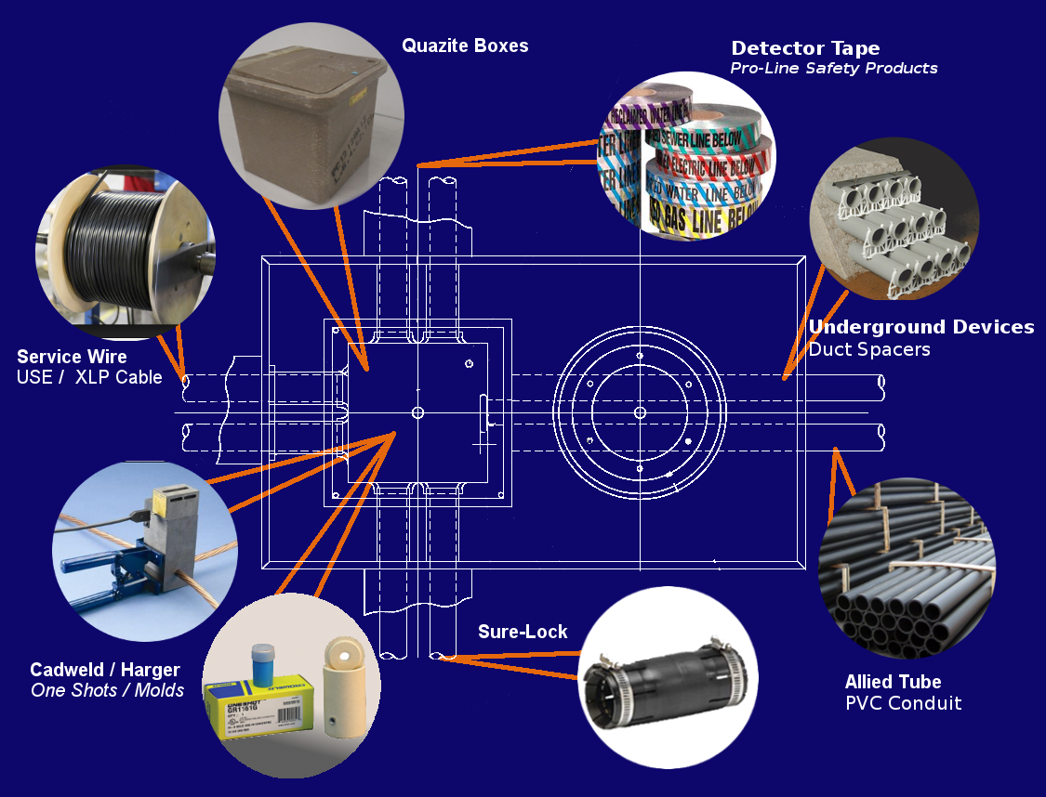
When you think Underground, think
Sunrise Electric Supply
- Cadweld and Harger Shots and Molds
- Quazite Boxes
- USE / XLP Cable
- PVC and Duct Spacers
- Sure-Lock Connections
- Detector Tape
- And the Highest Level of Service

(line card on back)

